**Abstract Template - Hints and Tips**

The following are hints and tips on completing the Faculty of Medicine Research Conference Abstract Template in Excel

These tips may be useful if you are unused to using Excel in this way

**Copying from Word**

If you wish to write the text of your abstract in Word, you can paste it into the relevant section of the template when you are ready.

Note that you will need to paste into the formula bar.

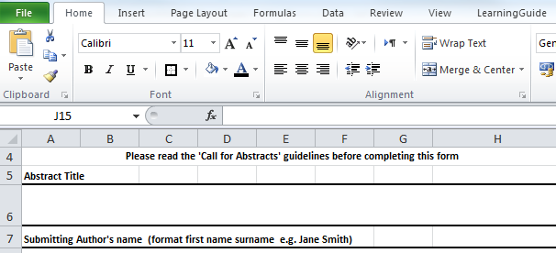

**Word count**

If you need to check the word count of your abstract the easiest way is to copy the text into a Word document.

*More detailed notes on completing each section of the template are on the following pages*

**Abstract title**

This is set at the standard font for submissions of 9 point Lucinda Sans. Please do not amend.

**Inserting symbols and special characters**

You can include symbols or special characters (e.g. ₣ or Ὠ) in your abstract title by doing the following:

When you need to insert a special character click on the ‘insert’ tab



Now click on the ‘Symbol’ button

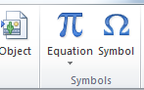

Locate and click on the symbol you need, and then click on ‘insert’.

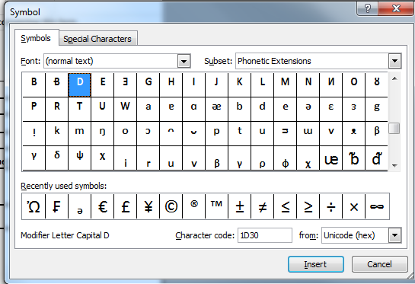

*Note – there is a separate tab for special characters*

**Submitting Author’s name**

Please type in the format first name surname (e.g. Jane Smith)

**Academic Unit**

Please select from the drop down options, by clicking the arrow, and then clicking on the appropriate unit..

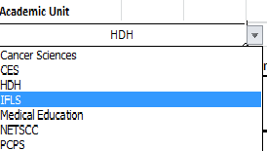

**Current Role**

Please select from the drop down options, by clicking the arrow, and then clicking on the appropriate level.



**Co-authors names**

Please type in the format first name surname, and separate each person with a comma (e.g. Jane Smith, Mark Jones)

**Lay Statement**

The lay statement should be a maximum of 150 words long.

**Bold and underlining**

If you wish to you can make some of the text in the lay statement section **bold** or under-lined, by using the relevant keys.



**Making a new paragraph**

You can make a new paragraph by holding down the ‘Alt’ key, and clicking the ‘return’ or enter ‘key’ twice.

**Making text subscript or superscript**

When you want to change to subscript or superscript in Excel you need to get to the ‘Format cells’ menu.

Either:-

Right mouse click, and then click on ‘Format cells’

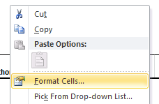

Or

Hold down the ‘Ctrl’ key, and click on the number 1 on the main keyboard.

From the following menu ‘tick’ whichever of superscript or subscript you require, and click on OK. When you need to revert to normal text repeat the process and remove the tick.

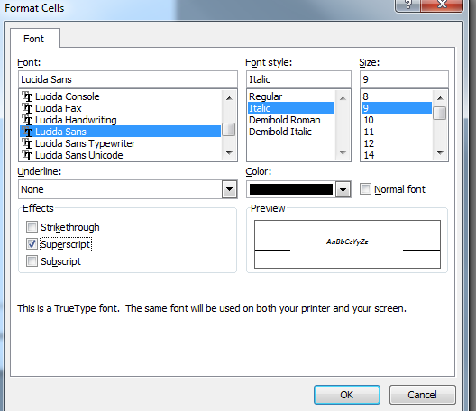

**Inserting symbols and special characters**

You can include symbols or special characters. Please see the notes above under ‘Abstract Title’

*NOTE – Text formating such as bold, superscript etc only shows in the Cell. Is does not show on the formula bar.*

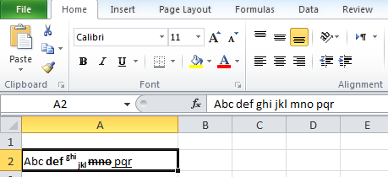

**Inserting bullet points**

Excel does not have a button for adding bullet points. However, bullet points can be added using the same method as for inserting a symbol or special character.

*NOTE - To go down one line to the next bullet point, hold the ‘Alt key, and click the ‘return’ or ‘enter’ key once.*

If you have already created a bulleted list in Word, and want to copy that bulleted list into Excel, do the following:

**Scientific Abstract**

The Scientific Abstract should be a maximum of 250 words long.

For hints and tips on completing this section using the excel template please see the section above on the lay statement.

**Email address for submitting author**

Please enter the email address we should use to contact you